PROJECT }:-> LIBRARY MANAGNMENT SYSTEM

**CODE:**

#include <iostream>

#include <conio.h>

#include <stdio.h>

#include <time.h>

#include <fstream>

/*--------------------librarian Credentials------------------*/

#define LIB_UN "admin"

#define LIB_PASS "12345"

/*------------------------------------------------------------------*/

using namespace std;

void My_details();

class book

{

protected:

/*----------------- add_books//view_books_list -----------------------*/

int book_id;

string book_name;

/*-------------- delete,borrow,return ----------------------*/

int rollno;

string name;

int b_id;

string b_name;

int issue_date;

int return_date;

int date, month, year;

time_t t = time(NULL); //get the time from os

struct tm tm = *localtime(&t);

public:

void add_book()

{

int n;

system("cls");

cout << "\n_____________________________________________________________________" << endl;

cout << "---->Enter how many books you want to add : " << endl;

cout << "---->";

cin >> n;

n--;

system("cls");

loop:

cout << "_____________________________________________________________________" << endl;

cout << "\t\t<----- Add Books ----->" << endl;

cout << "_____________________________________________________________________" << endl;

cout << " Enter the book id " << endl;

cin >> book_id;

cout << " Enter the book name " << endl;

cin >> book_name;

cout << "_____________________________________________________________________" << endl;

// writing data into the file or adding books to the list

ofstream add;

add.open("book_list.txt", ios::app);

add << endl;

add << book_id << endl;

add << book_name << endl;

add.close();

while (n != 0)

{

n--;

system("cls");

cout << "\n\t\t!!-->>Enter the next book<<--!!" << endl;

goto loop;

}

cout << "Books are added successfully to the list !!... (:+) \nPress any key to go back...";

getch();

}

void delete_book()

{

int n;

int b_id;

string b_name;

loop:

system("cls");

cout << "_____________________________________________________________________" << endl;

cout << "\t\t<----- Delete Books ----->" << endl;

cout << "_____________________________________________________________________" << endl;

cout << " Enter the book id " << endl;

cin >> b_id;

cout << " Enter the book name " << endl;

cin >> b_name;

cout << "_____________________________________________________________________" << endl;

ifstream bdata;

bdata.open("book_list.txt");

ofstream ndata;

ndata.open("book_list1.txt");

bdata >> book_id;

bdata >> book_name;

while (!bdata.eof())

{

if (book_id != b_id)

{

ndata << endl

<< book_id << endl;

ndata << book_name << endl;

}

else

{

cout << "\nRecord deleted successfully from the list !!... (:+) " << endl;

}

bdata >> book_id;

bdata >> book_name;

}

bdata.close();

ndata.close();

if (remove("book_list.txt") != 0)

{

cout << "\nFile does not remove" << endl;

}

else

{

cout << "File removed" << endl;

}

if (rename("book_list1.txt", "book_list.txt") != 0)

{

cout << "File renamed" << endl;

}

else

{

cout << "File renamed" << endl;

}

cout << "Press any key to go back...";

getch();

}

void view_book_list()

{

system("cls");

cout << "___________________________________________________________" << endl;

cout << "\t\t<---- Book List ---->" << endl;

cout << "___________________________________________________________" << endl;

cout << "---------------------------------------" << endl;

cout << "\tBook_Id | Book_name" << endl;

cout << "---------------------------------------" << endl;

ifstream view;

view.open("book_list.txt");

if(view.peek() == std::ifstream::traits_type::eof())

{

cout << "\n No Record found....!!!" << endl;

cout << "\n Add Books data." << endl;

}

else {

view >> book_id;

view >> book_name;

while (!view.eof())

{

cout << "\t" << book_id << "\t |\t" << book_name << endl;

view >> book_id;

view >> book_name;

}

cout << "---------------------------------------" << endl;

cout << "\n List ends here...!!" << endl;

}

void borrow_book()

{

int n;

system("cls");

cout << "\n_____________________________________________________________________" << endl;

cout << "---->Enter how many books you want to Borrow : " << endl;

cout << "---->";

cin >> n;

n--;

year = tm.tm_year + 1900;

month = tm.tm_mon + 1;

date = tm.tm_mday;

system("cls");

loop:

cout << "_____________________________________________________________________" << endl;

cout << "\t\t<----- Borrow a book ----->" << endl;

cout << "_____________________________________________________________________" << endl;

cout << "---------------------------------------------------------------------" << endl;

cout << "NOTE : You can borrow a book for only for 15 days.So return it \nwithin the duration of time unlees fine of Rs. 500 will be charged " << endl;

cout << "---------------------------------------------------------------------" << endl;

cout << "Enter your Roll No. : ";

cin >> rollno;

cout << endl

<< "Enter you name : ";

cin >> name;

cout << endl

<< "Enter the ID of the book you want : ";

cin >> b_id;

cout << endl

<< "Enter the book name : ";

cin >> b_name;

//Adding students info. who have borrowed a book to the list

ofstream sdata;

sdata.open("borrow_book_list.txt", ios::app);

sdata << endl

<< rollno << endl;

sdata << name << endl;

sdata << b_id << endl;

sdata << b_name << endl;

sdata << date << endl;

sdata << month << endl;

sdata << year << endl;

sdata.close();

while (n != 0)

{

n--;

system("cls");

cout << "\t\t!!-->>Enter the next book<<--!!" << endl;

goto loop;

}

cout << "Your information added successfully !!... (:+) \nPress any key to go back...";

getch();

}

void return_book()

{

int n;

system("cls");

cout << "\n____________________________________________________________________" << endl;

cout << "---->Enter how many books you want to Return : " << endl;

cout << "---->";

cin >> n;

n--;

year = tm.tm_year + 1900;

month = tm.tm_mon + 1;

date = tm.tm_mday;

system("cls");

loop:

cout << "_____________________________________________________________________" << endl;

cout << "\t\t<----- Return a book ----->" << endl;

cout << "_____________________________________________________________________" << endl;

cout << "Enter your Roll No. : ";

cin >> rollno;

cout << endl

<< "Enter you name : ";

cin >> name;

cout << endl

<< "Enter the ID of the book which you want to return : ";

cin >> b_id;

cout << endl

<< "Enter the book name : ";

cin >> b_name;

// adding the student data to the list

ofstream sdata;

sdata.open("return_book_list.txt", ios::app);

sdata << endl

<< rollno << endl;

sdata << name << endl;

sdata << b_id << endl;

sdata << b_name << endl;

sdata << date << endl;

sdata << month << endl;

sdata << year << endl;

sdata.close();

while (n != 0)

{

n--;

system("cls");

cout << "\t\t!!-->>Enter the next book<<--!!" << endl;

goto loop;

}

cout << "Your information added successfully !!... (:+) \nPress any key to go back...";

getch();

}

};

class librarian : public book

{

protected:

string Sname;

int Srollno;

public:

void student_bb()

{

system("cls");

cout << "_____________________________________________________________________" << endl;

cout << "\n-->Enter the student Roll No. : ";

cin >> Srollno;

cout << "\n-->Enter the student name : ";

cin >> Sname;

cout << "_____________________________________________________________________" << endl;

ifstream sdata;

sdata.open("borrow_book_list");

sdata >> rollno;

sdata >> name;

sdata >> b_id;

sdata >> b_name;

sdata >> date;

sdata >> month;

sdata >> year;

while (!sdata.eof())

{

if (rollno == Srollno)

{

system("cls");

cout << "_____________________________________________________________________" << endl;

cout << "\t\t>>>>Student Details<<<<" << endl;

cout << "_____________________________________________________________________" << endl;

cout << "Student name : " << name << endl;

cout << "Student Roll No. : " << rollno << endl;

cout << "Borrowed books by this student are mentioned below " << endl;

cout << "\t\t<---- Book List ---->" << endl;

cout << "-----------------------------------------------------------" << endl;

cout << "\tBook_Id | Book_name | Date" << endl;

cout << "-----------------------------------------------------------" << endl;

cout << "\t" << b_id << "\t |\t" << b_name << "\t |\t" << date << "/ " << month << "/ " << year << endl;

cout << "-----------------------------------------------------------" << endl;

}

else

{

cout << "\nRecord not found " << endl;

break;

}

sdata >> rollno;

sdata >> name;

sdata >> book_id;

sdata >> book_name;

sdata >> date;

sdata >> month;

sdata >> year;

}

sdata.close();

cout << "\nPress any key to go back...";

getch();

}

} l1;

int main()

{

// MAIN MENU

int login_choice = 0;

while (login_choice != 4)

{

system("cls");

cout << "_______________________________________________________________________________" << endl;

cout << "\t>>>>>>>>>>>>>>>>Library Management System<<<<<<<<<<<<<<<<<<" << endl;

cout << "_______________________________________________________________________________" << endl;

cout << ">>> Please choose any section given below to Enter:-)" << endl;

cout << "1. Coder details" << endl;

cout << "2. Student" << endl;

cout << "3. Librarian" << endl;

cout << "4. Close Application" << endl;

cout << "_______________________________________________________________________________" << endl;

cout << "Enter your choice :";

cin >> login_choice;

// <------------------------------Coder Details------------------------------->

if (login_choice == 1)

{

system("cls");

cout << "\t<----- Coder Details ----->" << endl;

My_details();

}

// <-----------------------------Student section------------------------------>

else if (login_choice == 2)

{

int student_choice = 0;

while (student_choice != 4)

{

system("cls");

cout << "_______________________________________________________________________________" << endl;

cout << "\t\t<----- Student section ----->" << endl;

cout << "_______________________________________________________________________________" << endl;

cout << "1. View Book list" << endl;

cout << "2. Borrow a Book" << endl;

cout << "3. Return a Book" << endl;

cout << "4. Exit" << endl;

cout << "_______________________________________________________________________________" << endl;

cout << "Enter your choice : ";

cin >> student_choice;

switch (student_choice)

{

case 1:

l1.view_book_list();

break;

case 2:

l1.borrow_book();

break;

case 3:

l1.return_book();

break;

case 4:

break;

default:

cout << "Invalid choice. Press any key to continue...";

getch();

}

}

cout << "Press any key to go back...";

getch();

}

//<-------------------------------Librarian Section---------------------------->

else if (login_choice == 3)

{

int lib_choice = 0;

string un;

string pass;

system("cls");

cout << "\t\t>>>>Admin Login<<<<" << endl;

cout << "+-----------------------------------------------+";

cout << "\n\tEnter your username : ";

cin >> un;

cout << "\n\tEnter your password : ";

cin >> pass;

cout << "\n+----------------------------------------------+";

if ((un == LIB_UN) && (pass == LIB_PASS))

{

while (lib_choice != 5)

{

system("cls");

cout << "_______________________________________________________________________________" << endl;

cout << "\t\t<----- Librarian Section ----->" << endl;

cout << "_______________________________________________________________________________" << endl;

cout << "1. Add Books " << endl;

cout << "2. Delete Books " << endl;

cout << "3. View Book list" << endl;

cout << "4. Student Data" << endl;

cout << "5. Exit" << endl;

cout << "_______________________________________________________________________________" << endl;

cout << "Enter your choice : ";

cin >> lib_choice;

switch (lib_choice)

{

case 1:

l1.add_book();

break;

case 2:

l1.delete_book();

break;

case 3:

l1.view_book_list();

break;

case 4:

l1.student_bb();

break;

case 5:

break;

default:

cout << "Invalid choice. Press any key to continue...";

getch();

break;

}

}

}

else

{

cout << "\nInvalid Credentials. :-( \nPrees any key to continue...";

getch();

}

cout << "\nPress any key to go back...";

getch();

}

else if (login_choice == 4)

{

cout << "Thank you for using it !!... {:-) " << endl;

exit(0);

}

else

{

cout << "\n\n Invalid Choice.\\__( * _ * )__/` Press any key to continue..";

getch();

}

}

return 0;

}

void My_details()

{

cout << "________________________________________________" << endl;

cout << "Name : Abhay Bindal" << endl;

cout << "________________________________________________" << endl;

cout << "Roll No : 181001" << endl;

cout << "________________________________________________" << endl;

cout << "Topic : Library Management System" << endl;

cout << "________________________________________________" << endl;

cout << "Email ID :abhay.181001@gmail.com" << endl;

cout << "________________________________________________" << endl;

cout << "College Name : Global Institute of Technology and Management " << endl;

cout << "________________________________________________" << endl;

cout << "Press any key to go back..." << endl;

getch();

}

Output:

**1st screen comes after running the program.**

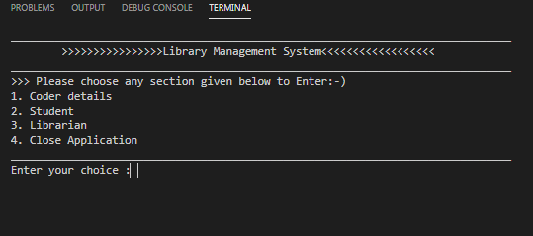

1. coder details(my information)

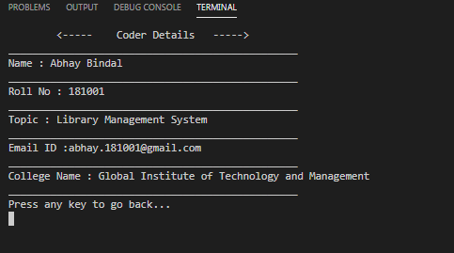

1. **Student**

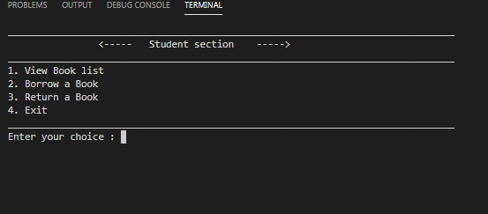

1. **Librarian**

**Login Page:-**

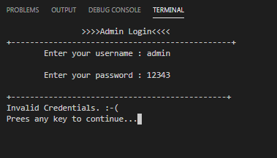

**Menu:-**

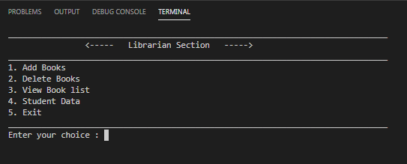

**View book list:-**

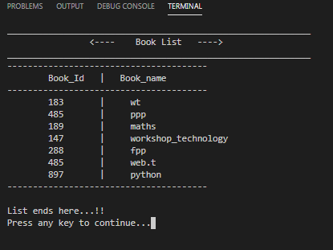

**Deleting a book:-**

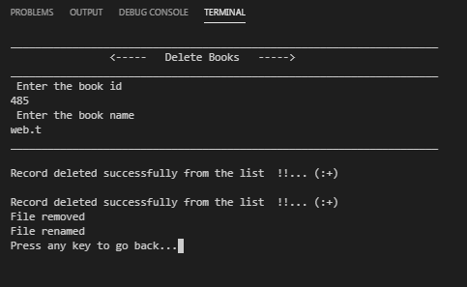

**updated list:-**

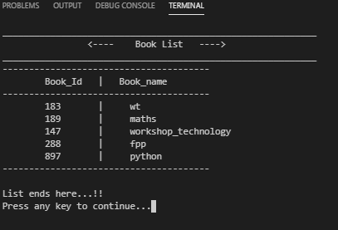

**Adding a book:-**

**1).**

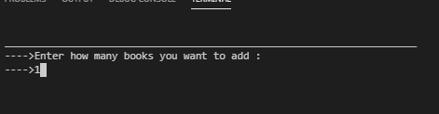

**2).**

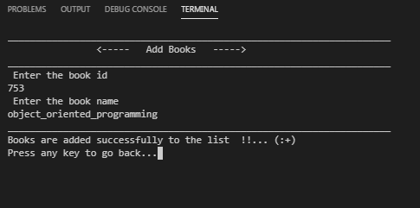

**3).updated list:-**

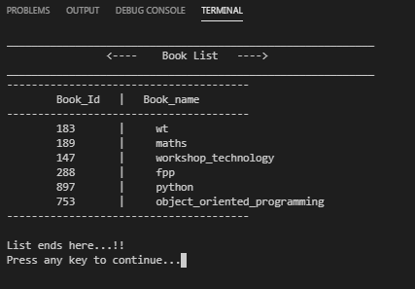

**Close application:-**

